IF YOU CAN"T BEAT EM>>>EAT EM!

The Chinese imported Mystery Snails Cipangopaludina chinensis as a favorite food. Originally brought into San Francisco in 1892, these mollusks have spread across the country, mainly by people who have discarded their aquariums into local ponds. This snail has also been a popular pet store item for years and is now also becoming popular with people who are establishing “water gardens.” Our recommendation, don’t use them except to munch on em.

This snail is primarily an algae eater. They “filter feed” by screening plankton out of the water. Consequently, they can help clarify small bodies of water like aquaria. They can also eat algae and other materials found on rocks and the pond bottom, especially if plankton becomes scarce. These live-bearing snails are popular in aquariums because they do not eat fish eggs or larger plants. They do not overpopulate aquariums, and they close up their covering door (operculum) if there is a water toxicity problem, giving aquarium hobbyists an indication that something is wrong with the tank a few weeks before the fish die. In the wild this feature makes them very resistant to drought and toxic materials. While they usually reproduce sexually there is recent information that these snails can become parthenogenic, which means that they can reproduce asexually, cloning live, genetically identical offspring. This gives them remarkable infestation potential, much like aphids, when food is plentiful.

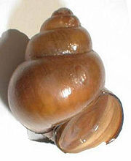

There’s a distinct possibility that quite a few of the populations found in water bodies near cities with large oriental populations have been established to develop a local food source. These snails are problematic for lots of reasons, mainly when dense colonies form around and in intake pipes clogging the flow of water. In our area they can wipe out indigenous snail species through competition and rapid reproduction.

Go back to my first sentence. These guys were so prized as food that many Asian cultures brought them and their recipes with them when they immigrated. If you’ve got them in your local pond, catch them; it’s easy to do since they like shallow water. However, if you try cooking them right out of the pond you’ll probably be disappointed with a muddy flavor. They need a bit of special treatment, like all edible snails, and here’s the secret.
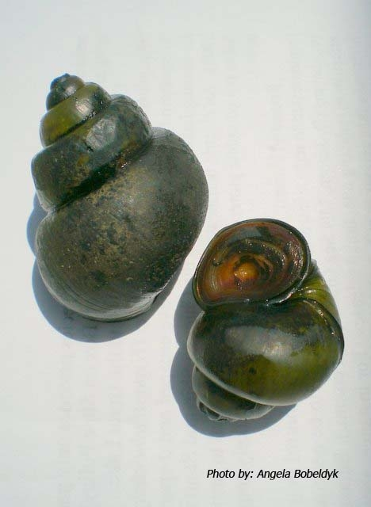

Once you have collected the snails, brush their shells with a stiff plastic bristle brush to remove any significant plant or slime materials. Then put them in a bucket of clean tap water (no chlorine or softener salt) and add a few flakes of oatmeal...depends on the number of snails in the bucket. You may have to cover the top with screening to keep em from climbing out. Cheesecloth and string usually works well enough. Change the water and add fresh oatmeal flakes each day for at least 3 days prior to cooking. Some folks will feed them oatmeal for a few days and then starve them for 3 days or so to clear them out. It's a bit of trial and error, but you'll eventually find a combo of feeding and starving that works well for you for the snails found in your pond. I used to feed our weinbergschnecken fresh basil and thyme, which perfumed their gut enough so that the whole beastie became very tasty. I never tried this with fresh water or marine snails, though. It’s good to think creatively, though.

Here's a tip. Once you have removed the soft parts from the cooked shell use only the rubbery foot. While the guts are somewhat edible, the flavor is acquired and not found desirable by most Euro ancestry folks (to me it tastes no worse than whole belly clams...but that's me!). My favorite way to eat them is in a black bean sauce over oriental noodles. Second favorite is as escargot with Gewürztraminer wine (like we used to make in Alsace), and third in a hearty tomato-based pasta.

People who have never eaten snails ought to go very lightly their first time as a few may have “seafood” allergies. I suggest trying a red clam sauce over linguine recipe for the molluscly uninitiated. If you use a burgundy-like cheap red wine like Gallo Hearty Burgundy and lots of garlic all will love it. These snails have a large enough foot that they can be chopped and used like chopped clams in any recipe.

These mystery snails really have a better taste than land snails like escargot or weinbergschnecken (which are really earthy unless heavily garliced) and are a good protein source...I suggest a cook-off with different recipes being tried and a resulting... cook book. They are usually very easy to collect. Who knows, munching them may make a dent in their population....

Having lived and worked in a wine growing area for many years I managed to accumulate a significant pile of shells.... Vineyards produce two good products; wine and snails...Enjoy them both together!

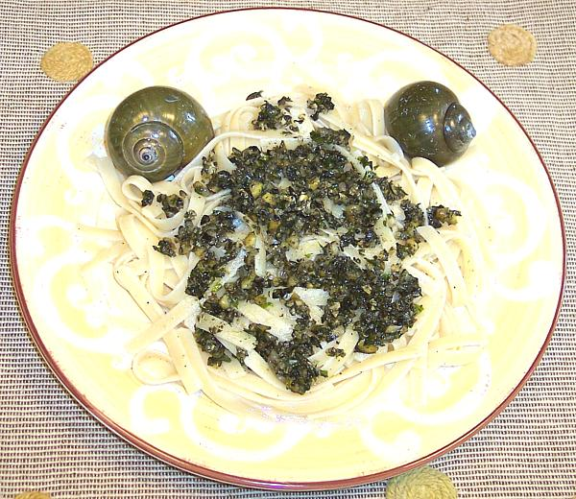

Here are a few good recipes for Mystery Snails from the web...Cook them qnd eat em up!

Never, ever eat a freshwater or land snail raw!……Earl

http://anhsfoodblog.blogspot.com/2007/05/wild-at-heart.html

http://www.clovegarden.com/recipes/9jf_snailpasta1.html

http://www.nguoi-viet.com/absolutenm/anmviewer.asp?a=51975

http://www.astray.com/recipes/?show=Escargot%20en%20croute

http://www.elook.org/recipes/asian/10287.html

http://www.ichef.com/recipe.cfm/recipe/Snails,%20Portuguese%20Style/task/display/itemid/83759/recipeid/83421

http://www.bigoven.com/39227-Black-Bean-Ragout-with-Snails-recipe.html

http://www.blogjam.com/2005/08/02/garden-snail-risotto/

http://blogs.myspace.com/index.cfm?fuseaction=blog.view&friendID=299948943&blogID=340173183

http://www.bigoven.com/108950-Manila-Clams-with-Black-Bean-and-Ginger-Sauce-recipe.html

