Building a Home-Made Deep-Water Sampler ….Earl Morse

You will need to have a deep-water sampler if you are trying to get information about temperature stratification, pH, bacteria and transparency profiles, some chemicals, turbidity etc. While most samplers are quite expensive, this device can be built for less than five dollars. About the only sample that this device can’t be used to collect is dissolved oxygen. If you are on line when reading this article, click here to download a movie to see how the sampler is operated (LARGE FILE 10+ MEG). Go to the Maine COLA website first if you are reading a paper copy.

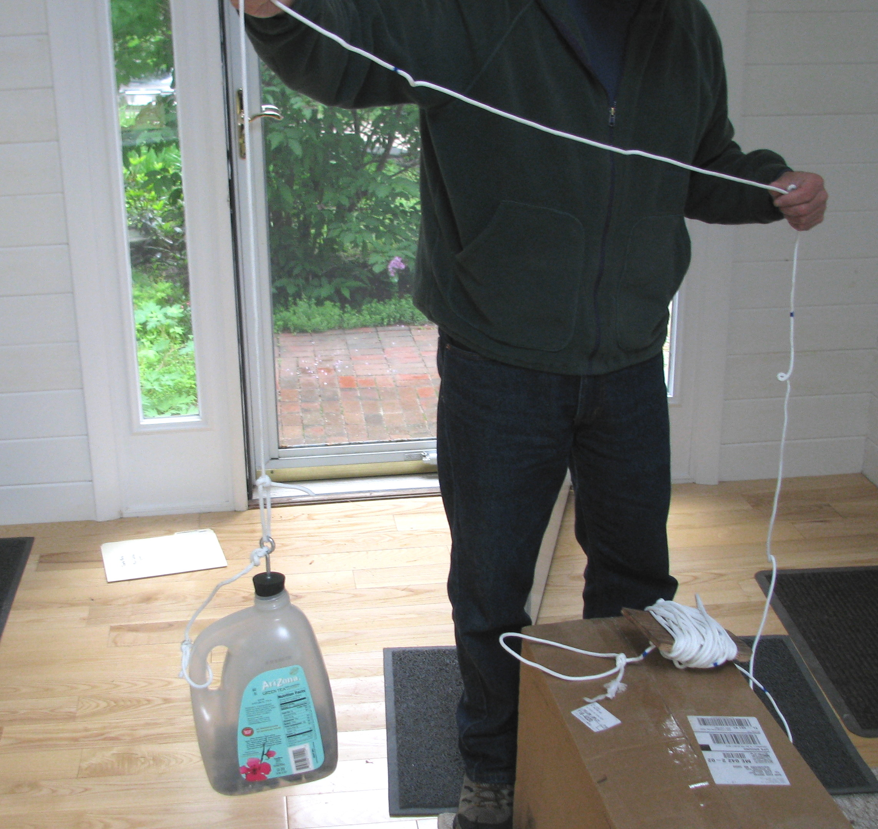

The plastic jug is simply slowly lowered into the water to the desired depth, the line given a strong enough jerk to dislodge the stopper. You then wait until bubbles no longer reach the surface and haul the sampler into the boat. You can then record temperature, pH and pour out samples needed for other procedures.

Materials needed:

[ ] Heavy plastic jug with molded handle. An Arizona Iced Tea jug works well.
[ ] Fifty to one hundred feet of rope. One that doesn’t stretch much.
[ ] A number 8 neoprene stopper with one hole. A second hole will be drilled through the stopper close to the small edge with a ¼” bit.
[ ] An eye bolt (1/4 diameter 20 threads per inch pitch) 3 inches long or similar.
[ ] Nylon collar nut and flat washer for above. Or standard nut and Lock-tite locking liquid and washer.
[ ] Enough clean rock to sink jug when placed inside.
[ ] Electric drill and ¼” bit.

[ ] optional digital kitchen thermometer

Construction:

Drill a ¼” hole through the stopper close to the outside edge of the small end. Move drill back and forth a few times to clean out the hole. Insert the eyebolt completely through the large side of the stopper. Place the washer on threaded end and fasten the nut so it’s putting light pressure on flat surface of the small end. If you are not using a nylon collar nut use a drop of Lock-tite to lock the nut onto the thread. Be sure that the washer does not block the drilled hole.

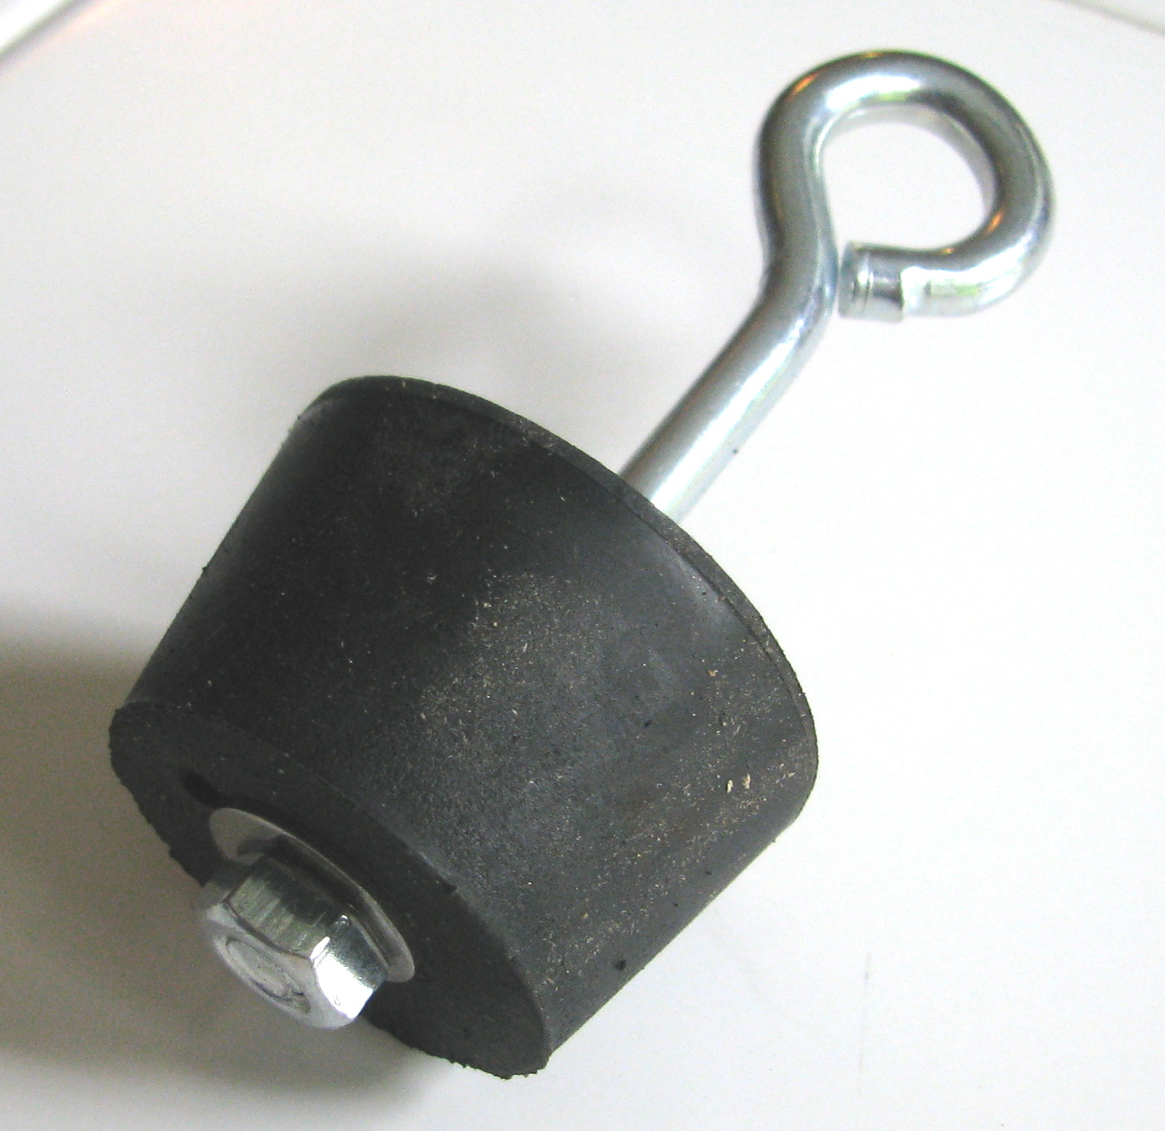

Connect a section of rope between the handle of the plastic jug and the eye of the bolt. The rope should be long enough to leave a slack arc between the eye and the handle.

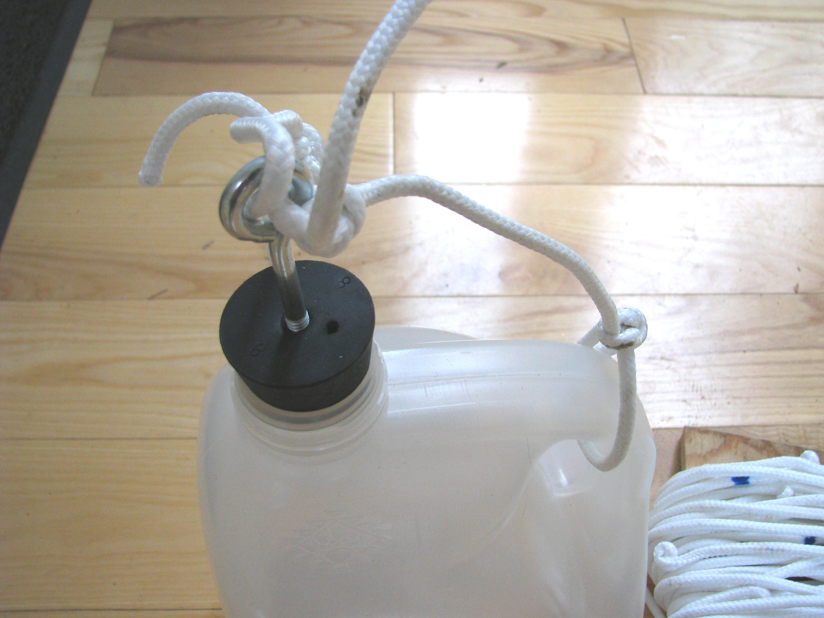

Tie a 50 to 100 foot rope to the eye. This rope should be marked with an indelible marker every one-meter starting from the eye. Using these marks you will be able to trigger the stopper at selected depths by jerking the cord. Wind this long rope onto a flat piece of wood to ease deployment.

Take the sampler to a nearby pond and add enough clean, crushed stone to cause the sampler to just sink.

TO USE THE SAMPLER:

- Be sure that the sampler is free of as much water as possible.
- Press the stopper firmly into the sampler mouth with both hands
- Slowly lower the sampler into the water till you reach the desired depth. You will not some bubbles at air is pushed out of the container as it descends. Work slowly and allow the air to escape. The sides of the container will crush a bit as the water pressure rises it will flow out of the ¼ inch drilled hole. The Arizona Iced Tea container was selected because it is sturdy and will give without crushing beyond repair.
- When your slightly crushed container reaches sampling depth jerk the line to release the stopper. The container will restore its shape and fill with water from the depth being sampled. You will see a burp of large air bubbles at the surface after a few seconds. Once these bubbles stop you may haul the sampler to the surface and perform your tests or save your samples.

The triggered sampler is shown in the picture below. Note the rocks inside.

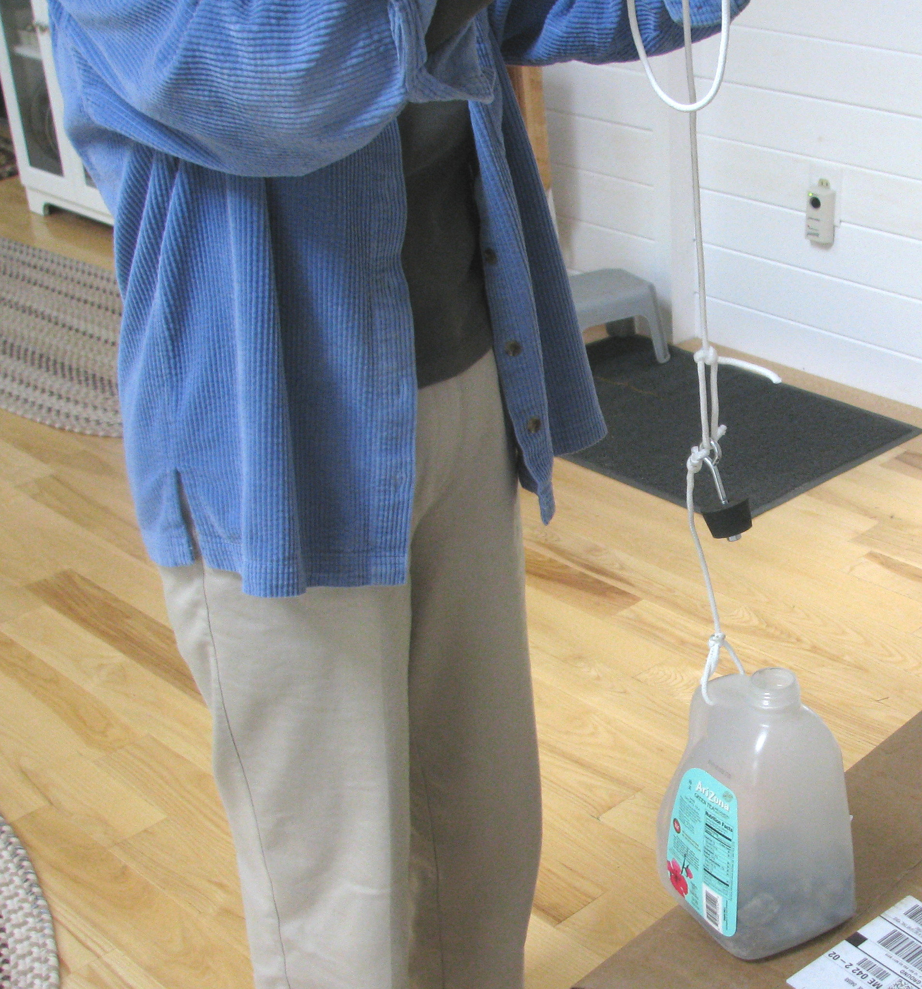

NOTES ABOUT USING A DIGITAL THERMOMETER:

Excellent digital cooking thermometers can now be purchased costing from 8 to 15 dollars. They can often be read in Celsius or Fahrenheit and frequently have ranges from –45 to 250 degrees Celsius or –50 to 400 degrees Fahrenheit to a tenth of a degree. The one shown below cost $13 and came from Hannaford. In any case, it’s a good idea to calibrate the thermometer to know how much of a reading error it has. Collect some rainwater in a couple of ice cube trays and freeze it. Place the ice cubes in a small pot and add rainwater until the ice cubes just begin to float free. Immerse the probe into the ice mix and slowly stir the mix while driving the temperature down. Drive the temperature as low as possible (all the while stirring) and note the reading. We will assume this is really zero degrees or the freezing point. Your lowest reading should be within + or - 1.5 degrees C of zero. Use this value as a fudge factor and adjust your readings upward or downward. In the photo below we were able to drive the temperature to –0.1 C so we now know that we have to subtract one tenth of a degree from the reading on the read-out. I think it’s incredible how accurate cheap these electronic devices can be. Note that in the picture below the thermometer is resting against the side of the bowl. Within 2 seconds of stirring stoppage the thermometer rose from –0.1 to 0.0 C. I happen to have a very expensive, standards-calibrated mercury lab thermometer that reads from –10 to 50 C…this cheap digital performed dead on with the expensive lab thermometer.

