Mystery Snails: IF YOU CAN"T BEAT EM>>>EAT EM! (18 Jan 2011)
... Earl Morse

The Chinese imported Mystery Snails Cipangopaludina chinensis as a favorite food. Originally brought into San Francisco in 1892, these mollusks have spread across the country, mainly by people who have discarded their aquariums into local ponds. This snail has also been a popular pet store item for years and is now becoming popular with people who are establishing “water gardens.” Our recommendation, this is an invasive species, so don’t use them except to capture them and munch on em if they exist in a pond near you. They can be found in many lakes in Maine.

This snail is primarily an algae eater. They can feed by removing micro plankton from fresh water by a filtration type of process. Consequently, they can help clarify small bodies of water like aquaria. They can also scrape off and eat algae and other materials found on rocks, emergent plants and the pond bottom, especially if plankton becomes scarce. These live-bearing snails are popular in aquariums because they do not eat fish eggs or larger plants. They do not overpopulate aquariums, and they close up their covering door (operculum) if there is a water problem, giving aquarium hobbyists an indication that something is wrong with the tank a few weeks before the fish die. In the wild this feature makes them very resistant to drought and toxic materials. They usually reproduce sexually, but there is recent information that these snails can become parthenogenic, which means that they can reproduce asexually, cloning live, genetically identical offspring. This gives them remarkable infestation potential, much like aphids, if food is plentiful.

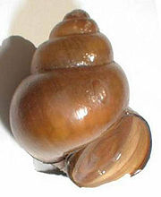

Quite a few of the populations have been found in water bodies near cities with large oriental populations. So there’s a distinct possibility that the snails have been established to develop a local food source. These snails are problematic for lots of reasons, mainly when dense colonies form around and in intake pipes, subsequently clogging the flow of water. In our area they can wipe out indigenous snail species through competition and rapid reproduction.

Going back to my first sentence; these guys were so prized as food that many Asian cultures brought them and their recipes with them when they immigrated. If you’ve got them in your local pond, catch them; it’s easy to do since they are big and like shallow water. However, if you try cooking them right out of the pond you’ll probably be disappointed with a muddy flavor. They need a bit of special treatment, like all edible snails.
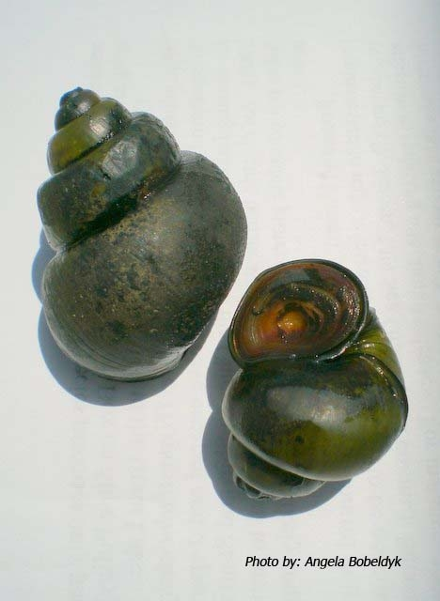

Here’s the secret. Once you have collected the snails brush their shells with a stiff plastic bristle brush to remove any significant plant or slime materials. Then put them in a bucket of clean tap water (no chlorine or softener salt) and add a few flakes of oatmeal...depends on the number of snails in the bucket. You may have to cover the top with screening to keep em from climbing out. Cheesecloth (or an old t-shirt) and string usually works well enough. Change the water and add fresh oatmeal flakes each day for at least 3 days prior to cooking. Some folks will feed them oatmeal for a few days and then starve them for 3 days or so to clear them out. It's a bit of trial and error, but you'll eventually find a combo of feeding and starving that works well for you for the snails found in your pond. I used to feed our Weinbergschnecken (German for escargot) fresh basil and thyme, which perfumed their gut enough so that the whole beastie became very tasty. I never tried this with fresh water or marine snails...
Once the snails have been brushed clean, fed in clean water for at least 3 days and starved for about 3 day they may be cooked. Place them in a pot, cover them with water and boil them till the operculum comes off easily. It should just about fall off. Remove the meat from the shell with an unscrewing motion. Once you have removed the soft parts from the cooked shell use only the muscular foot. While the guts are somewhat edible, the flavor is acquired and not found desirable by most Euro ancestry folks (to me it tastes no worse than whole belly clams...but that's me!). Rinse the foot in cool water and use it in the recipe. You may wish to chop the foot to help it become tender. If the meat retains a strong algae odor, boil the cleaned feet (foots?) with a bullion cube for 10 minutes before using them in the recipe.

My favorite way to eat them is in a black bean and ginger sauce over oriental noodles. Second favorite is in a hearty burgundy-laced tomato-based (marinara) pasta.

People who have never eaten snails ought to go very lightly their first time as a few may have seafood allergies. I suggest trying a red clam sauce over linguine recipe for the molluscly uninitiated. If you use a burgundy-like cheap red wine and lots of garlic all will love it. These snails have a large enough “foot” that they can be chopped and used like chopped clams in any recipe.

These mystery snails really have a better taste than land snails like escargot (which are really earthy unless heavily garliced) and are a good protein source...I suggest a cook-off with different recipes being tried and a resulting... cook book. They are usually very easy to collect. Munching them may make a dent in their population....

Having lived and worked in a wine growing area for many years I managed to accumulate a significant pile of shells.... Vineyards produce two good products; wine and snails...Many of our ponds have the snails...so we're halfway there. Enjoy them both together!

Here are a few good recipes for Mystery Snails from the web...Cook them and eat em up!

Never, ever, eat a freshwater or land snail uncooked! Almost all freshwater fish and molluscs have parasites that are not killed till well cooked. Never eat freshwater fish or molluscs raw!

http://www.nguoi-viet.com/absolutenm/anmviewer.asp?a=51975

http://www.astray.com/recipes/?show=Escargot%20en%20croute

http://anhsfoodblog.blogspot.com/2007/05/wild-at-heart.html

http://www.ichef.com/recipe.cfm/recipe/Snails,%20Portuguese%20Style/task/display/itemid/83759/recipeid/83421

http://www.bigoven.com/39227-Black-Bean-Ragout-with-Snails-recipe.html

http://www.blogjam.com/2005/08/02/garden-snail-risotto/

http://blogs.myspace.com/index.cfm?fuseaction=blog.view&friendID=299948943&blogID=340173183http://www.clovegarden.com/recipes/9jf_snailpasta1.html

http://www.bigoven.com/108950-Manila-Clams-with-Black-Bean-and-Ginger-Sauce-recipe.html

