Activity 12: Become a Super-Sleuth: How to Make and Use a dichotomous (two choice) key. to identify 11 common Maine invasive aquatic plants and/or benthic invertebrates.
(Version 29 November 2010)
Notes to the teacher:

What is a Dichotomous Key?

Dichotomous keys are commonly used by environmental scientists to identify and distinguish amongst organisms collected during surveys. While many different dichotomous keys exist, they all have one thing in common, they only ask the investigator to distinguish one characteristic at a time. Either the organism in question has the characteristic or it doesn't have the characteristic. This sets the dichotomy. If the organism in question has the characteristic the key leads you down one path toward identification. If it doesn't have the characteristic it takes you down an alternate identification path.

In this activity your students will begin the development of their own dichotomous keys. This is done in preference to showing kids how to use a key because it requires a higher level of thinking to develop a key rather than simply use one. If a student develops a key she is much more likely to internalize the distinguishing characteristics and develop expertise as a scientific identifier (scientists who specialize in identification are called taxonomists).

Practice key development with objects from home.

Divide students into groups of four to five kids. Ask each student to bring in a couple of non-breakable, valueless objects from home so that each team has exactly 10 objects. No object should be larger than a coffee cup. (As an alternative you could use ten rocks from the yard)

Each group should work at its own table. A large piece of newsprint and a washable felt marker should be provided each team.

Task: Make a key to distinguish all ten objects.

- Develop distinguishing characteristics that would eventually isolate each of the ten objects.
- Use the newsprint paper to lay out the key with the distinguishing characteristics written at each decision branch.

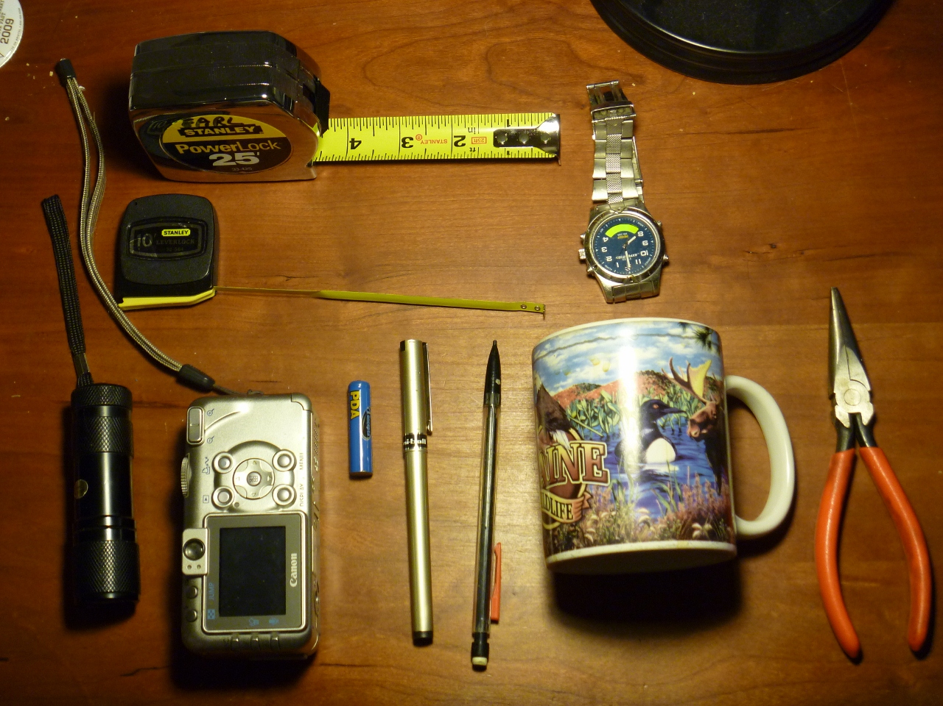
In the above photo we could split the group of 10 objects many ways

“has fabric strap”:”does not have fabric strap” distinguishes the camera and flashlight from the other eight objects

From the two objects in the “has fabric strap” group the characteristic “is cylindrical in shape” would distinguish the flashlight from the camera. That is the flashlight “has fabric strap” and “is cylindrical in shape” keys us to the flashlight whereas “has fabric strap” and “is not cylindrical in shape” leads us to the camera. Now we could start to distinguish amongst the “does not have fabric strap” group till we have isolated all objects. The test of the key is to give the key and the set of objects to others to use successfully.
All ten objects
|
< has fabric strap> - - - - - - - - - - - - | - - - - - - - - - - - - - - <does not have fabric strap>
flashlight, camera |
| |
<is cylindrical in shape> - - - - - <is not cylindrical in shape> |
flashlight camera |
|
pliers, pen, pencil, cup, battery, 25 foot tape, 10 foot tape, watch
|
<waterfowl picture on exterior> - - - - - <no waterfowl picture on exterior>
coffee cup remaining seven objects
Now, we'll do this with either the 11 most common invasive aquatic plants found in Maine or Creatures commonly found in Hester-Dendy Samplers. It's your choice and will depend on which on-the-water experience you will be preparing with your class.

First, you and your kids will need to have access to resources to help you learn about the ecology of organisms you are likely to find:

If you are working with benthic macro-invertebrates as part of your on-the-water experience we suggest downloading a printing a few copies of the University of Wisconsin Extension Service's excellent publication. It's not exhaustive, but it's fun and easy to read:

Wonderful, Wacky, Water Critters. This 27-page booklet includes background ecology information on some of the macroinvertebrates and other creatures commonly found in the river and pond keys. http://clean-water.uwex.edu/pubs/pdf/wwwc.pdf

A nice macro-invertebrate slide show from Washington State may be found at:

http://www.bgsd.k12.wa.us/hml/jr_cam/macros/macro_id-htm/slide_01.htm

If you are going to work with invasive plants you will want to download and print the VLMP's (Maine Volunteer Lake Monitoring Program) guide to aquatic invasive species:

Maine's Interactive Field Guide to Aquatic Invaders and Their Native Look-Alikes
http://www.mciap.org/herbarium/

Other useful resources are linked to the Maine COLA website.

Take a close look at the following sample keys:

(Good benthic invertebrate keys for photocopying from the U. of Wisc. Extension Service:)

River Key http://watermonitoring.uwex.edu/pdf/level1/riverkey.pdf
Pond key: http://watermonitoring.uwex.edu/pdf/level1/pondkey.pdf

What do you need to know about organisms to make your own key?

Make a list of the characteristics that are used to distinguish amongst the creatures in the above examples. If your on-the-water experience will focus on diversity and benthic invertebrates use the VLMP Aquatic Invaders Guide for practice. If your on-the-water experience will focus on exotic invasive plants use the river or pond key for practice.

For plants a few characteristics are:

for benthic invertebrates a few examples are:

Are there other distinguishing characteristics you might use?

Are there characteristics that are probably not very useful for distinguishing amongst. See if you can come up with a couple of examples.

What special tools do you need if you have real samples?

White trays deep enough to hold an inch or two of water, magnifiers or stereo microscopes, spoons (to sort crawlies), lots of small jars (like baby food jars), glycerin and ethanol (to preserve specimens), pencils, scissors, index cards.

Making Your Own Dichotomous Key:

Find the “best” descriptive characteristics of either these plants:

We're asking you to go to the Web and find good photos and descriptions of the following invasive aquatic plant species found in Maine:

European Frogbit (Hydrocharis morsus-ranae)
Water Chestnut (Trapa natans)
Yellow Floating Heart (Nymphoides peltata)

Fanwort (Cabomba Caroliniana)
Eurasian Water-Milfoil (Myriophyllum spicatum)
Variable Water-Milfoil (Myriophyllum heterophyllum)

Parrot Feather (Myriophyllum aquaticum)

Brazilian Waterweed (Egeria densa)
Curly-leaf Pondweed (Potamogeton crispus)
European Niaid (Najas Minor)
Hydrilla (Hydrilla verticillata)

Or a few of the animals commonly found in our Hester-Dendy Samplers:

round worm
leech (or segmented worm)
Stonefly nymph
Caddis fly nymph (case caddis)
Caddis fly nymph (free-living)
Dragon fly nymph
Damsel fly nymph
Mayfly nymph
Alderfly nymph
snail
beetle (Coleoptera)
midge (Diptera)
mite

Compare and Contrast: Now use those characteristics to develop a dichotomous key of your own.

Use the web to find good pictures of each organism. Print them and make a picture set. Place a number on the back of each picture. Draw your key on a large piece of blank newsprint paper.

Testing your home-made key to see how well it works.

Trade your key and picture set with another group. Ask them to try the key out and sort your picture set. Don't expect them to get it exactly correct. If they don't get it correct show them the correction and ask them help you provide better distinguishing choices.

Try the key out on a different set of people and see if it works better.

It should work fairly well after the second trial.

Good keys for photocopying from the U. of Wisc. Extension Service:

River Key http://watermonitoring.uwex.edu/pdf/level1/riverkey.pdf
Pond key: http://watermonitoring.uwex.edu/pdf/level1/pondkey.pdf

