Activity 5. Stewardship of an Exotic Specie's Invasion in Your Town. Activities that parallel on-the-water aquatic invasive studies using the same content and skills (ver. 3 December, 2010)

Finding, measuring and mapping and managing a highly disruptive invasion of Japanese Knotweed Fallopia japonica (also called Polygonum cuspidatum) in your community.

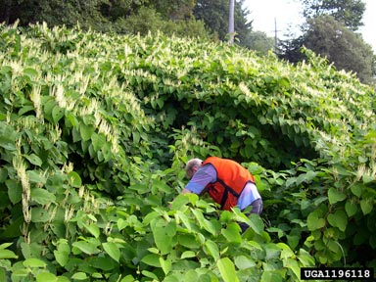
Why a Japanese Knotweed stewardship activity in an aquatic invasives program? The following activities focus on Japanese Knotweed (JK), a terrestrial rather than aquatic species. This plant was selected because on-the-water invasive plant activities during the cold months of the school year are difficult. In many ways the invasion of JK parallels the case histories of our more serious aquatic invasives species, specially the milfoils and hydrilla. Many of the control measures used on the aquatic invasives can be tried on this knotweed. All of the activities below, while terrestrial, have equivalents in the management of aquatic invasive plants. Getting involved will prepare your students for their on-the-water experiences.

By the way, if your kids don't find any JK in your school district you have accomplished a major “whew” for your community, just like the sigh of relief aquatic invasive hunters get when we determine that a lake is free of invasives, even though the sigh is likely to be temporary. Be sure to get local press publicity for your stewardship. Since re-invasion will continue even with the best management practices, you may wish to get into the project annually. These easily spotted plants will eventually become established somewhere in your area and kids are, after all, your community's best local explorers. Feel free to take as large or a small a stewardship bite as you wish. We do not anticipate that any one class will become involved in the entire scope of this activity. If you find this knotweed and provide landowners with information on how to eradicate it you have done well (Phase 1.)! The knotweed issue is just like the aquatic invasives issue; identification, control and re-invasion is a continuous task. Training your kids as observers will allow them to contribute information even when they have left your class! We will do our best to connect you with local lake association members who are already involved with aquatic invasives management, especially since you may, as a result of your participation in this project, be invited to on-the-water activities in aquatic invasives study and management.

A little background: Japanese Knotweed is a seriously invasive plant that is spreading throughout Maine. In areas of the US where it has been longer established its presence can be overwhelming. It can be found in most school districts in Maine and is easy to spot, map, and measure, even in moderate snow as the dead stalks are tall (up to 10 feet high) and bamboo-like.

It is used by the Japanese as a food crop and a tea (Itadori), but was brought into this country by ornamental gardeners, various state DOT's and the US Army Corps of Engineers as an erosion control plant. It is an escapee. The flowering thicket in late summer can be quite beautiful, but don't be deceived, the plant is extremely aggressive, very difficult to eradicate, and can be very damaging to man-made structures like walls and foundations. Seeds are small and spread by wind. The turbulence produced by passing vehicles (specially trucks) will loosen seeds and the vehicle itself will often transport the seeds down the road. JK has been established in Europe and the U.K. For a longer period than the U.S. and a YouTube video search will quickly illuminate the issues. In parts of the U.S. (like western Pennsylvania) it has been established for years, is the most common roadside plant, and is totally out of control. The seeds are also easily distributed by water, too, and, “Large stands have been noted in western Pennsylvania, in particular along the banks of the Ohio and Allegheny Rivers and on the islands in these rivers where it occupies hundreds of acres of wetlands, stream banks, and hillsides.” In many respects it is the roadside equivalent of aquatic invasives like hydrilla and the invasive milfoils. In Maine, Japanese knotweed is documented in every county except Piscataquis and Hancock. There's no doubt that it will be found there soon (it has probably already been found by the time you've read this). It has no natural enemies here, yet, and like aquatic plant invasives is very,very difficult to eradicate.

Edibility: In the spring the shoots come up early and are edible, sour but good tasting, and easy to crop. It is milder than rhubarb in tartness and is enjoyed by most people who have tried it. You may choose to investigate the edibility of the plant in the spring. For that purpose we have included an Appendix activity called, “If you can't beat them eat them.” The edibility may help your class understand the possible use of browsing as a control measure. JK looks a bit like bamboo and tastes a bit like asparagus and rhubarb. Like rhubarb the mature leaves contain oxalic acid and should not be eaten.

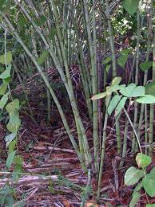
What makes it special is its healthy nature. Japanese Knotweed is chock full of vitamin C and resveratrol. Resveratrol is the nutrient in red wine that scientists are starting to believe has the ability to extend life. The best time to prepare and eat Japanese Knotweed is in the spring when the new shoots are around 6 to 8 inches tall. Like rhubarb, the leaves should be discarded and not eaten. The young stalks are used to prepare a number of dishes. If you get to the plant after it has exceeded a height of 8 inches, most often the stalks are covered by a very tough rind and are not worth processing. Before you get involved in eating any wild plant please consider that eating any new vegetable poses some allergic risk. The teacher should try it at home and find a recipe that kids will like. Permission should be obtained from parents before any kid eats any wild food in school. First trials should be minimal (less than a teaspoon) with an overnight pause for possible reactions before eating more. The first time, no one should have more than a small portion. The good news is that the plant WILL become more abundant as it invades Maine and will make a nutritious supplement to anyone's diet. However, is this really good news?

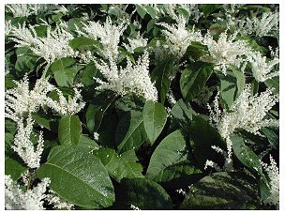
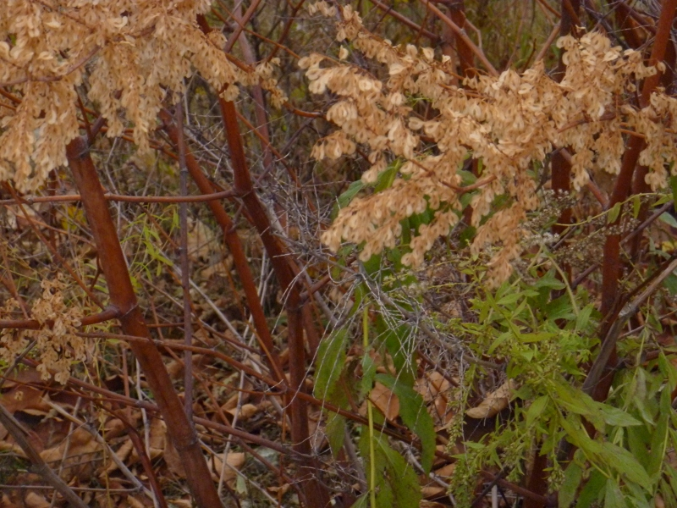
Japanese Knotweed flowers toward the end of summer (photo above left) and is quite beautiful in November with reddish stalks and red-silver seeds.

The plant is very easy to recognize any time of year and tends to be readily established in roadsides. This gives people who daily prowl the highways an advantage since it can be spotted quickly once it has been established. Teams of trained observers scouting the by-ways daily in large yellow vehicles (school buses) are real resources to the hunting effort.

Here's a nice video of a stand of knotweed found along a roadside. It will familiarize you with the plant and is well worth watching. http://www.youtube.com/watch?v=IG2z7IqPHTE

There's a Gulf of Maine Research Institute video showing what to look for in the spring at
http://www.youtube.com/watch?v=Of7z5IB1Ud4

Because the plant is visually distinctive I've been able to spot a good number of JK stands by viewing roadways using Google Earth's “street view” made by roving, camera-mounted cars. There a nice small flowering stand at lat 43.933395, Lon-70.575986 close to the Songo Locks on Sebago Lake where there is also a huge invasive aquatic milfoil infestation. Wow! Plug those numbers into Google Earth and check it out.
A Baseline Study.

Phase I. Knotweed hunting (How do you recognize an invasive plant when you see one?):

Hunting on the web:

How to know one when you see one (recognizing Japanese Knotweed)?
We need to train our spotters. Break your class into web-hunting teams with three or four members to each team. Each team should be assigned just one task. Here are a few questions you might want to assign, other questions will come up as kids learn more about the plant. The fewer questions you pose and the more question generated by kids, the better. Kids need to share their new questions and findings via discussion and a classroom bulletin board. Kids “findings” should always be posed as their question (and their answer) on the bulletin board. E.g. if kids find and print good flower pictures on the web the caption should read, “what do the flowers look like?” and “What time of year can they be found?”

What does the plant look like in the spring? In the summer? In the winter? What stays alive in the winter? How does it keep alive from year to year?

What do the flower buds and flowers look like? When can they be seen? What do the seeds look like and how do they spread?

What do the leaves and stems look like?

What does the underground growth look like? Does this affect the spread of the stand?

How does a stand spread? Where does the plant usually grow? Does it like sun or shade?
Does it like wet soil or dry (well drained soil), disturbed soil or undisturbed soil?

The class bulletin board should have clear photos taken from the websites showing the web address (URL) where the photo information was found. For hundreds of photos go to Google click “pictures” and enter Japanese Knotweed into the search bar.

Are they Here? Hunting around your school district by bus:

Once students can recognize the plants they can hunt for it from their school buses and when they travel around town. Be sure to brief the bus admin office of this project before it starts. Driver cooperation is very helpful to this project, specially if your buses are GPS equipped. Since the plant flowers in late summer and early fall this hunting activity is a good school-year starter activity for your kids.

Step 1. Individual map preparation. Each student should go to a web-based map site like Mapquest, GoogleMaps or GoogleEarth (needs software installation, but is best!), Yahoo Maps etc, and produce a map the path of their bus route from school to their pick-up point. Make sure that there is a scale on the map so that approximate distances from known landmarks (like intersections) can be plotted on their individual maps. Your school bus administrator can verify that the routes are correct.

Step 2. Classroom map preparation. The class will prepare a composite mosaic map of the school bus routes for use as a wall display in your classroom. All pages of this mosaic must be printed to the same scale. This will be used to note where knotweed patches have been found in the school district.

Step 3. The hunt. When a student thinks they have found an established stand of JK they should locate it on their map and transfer the location to the larger school bus route map. Google Earth has the ability to “pin” or place gps latitude and longitude locations directly on the map. If possible, the stand should be photographed from the bus or roadside (with the bus stopped) and the photo placed on the map with a ribbon connecting it to the exact map location. If possible a yardstick or meterstick should be included in the photos as below. Students and bus drivers must be briefed so that students do no enter private property to take the photo. Some school districts have gps devices on their buses so that the geographic coordinates of any roadside site can be accurately located.

The photo below was taken in mid-October and includes a meter stick. It shows a somewhat triangular stand that is 9.5 meters long and 6.5 meters wide. You can use the meter stick to measure the length dimension in the photo.
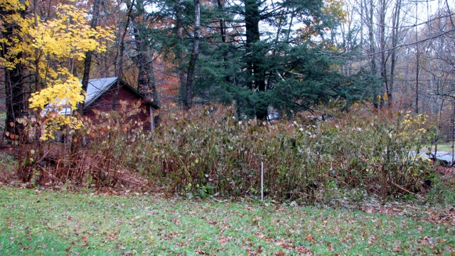
Step 4. Verification. The class will prepare a one page document on how to identify JK for use by bus drivers, parents and other community adults. Other students or the bus driver should visit the site by bus route and verify or confirm that they, too, think the identified stand is Japanese Knotweed. If this is done in September the flowering stand will be easy to confirm.

Step 5. Stewardship: Producing and Disseminating JK control information. Students will prepare and distribute printed information on how to eradicate JK for use by landowners who have the plant on their property.

Baseline Study. Phase II. Estimating the area covered by of a “stand” of Japanese Knotweed.

How large and area does the stand cover? Measuring the size of the knotweed stand. If the stand is on private property, an adult needs to get permission for students to measure the stand and photograph it closely. While bus drivers may volunteer to help, this is best done by parent-child teams on week-ends. We hope to engage Lake Association members in mentorship, too. For our control activities later in this unit we only need one stand to investigate and the property owner needs to be willing to collaborate in eradication efforts and student studies. Often the stands are already too large to study. Try to find a stand that does not cover an area of more than about 400 square feet.

Preparatory work:

Estimating distances: Unless they have access to long tape measures, kids need to be able to estimate distances in order to approximately measure the size of a stand. It is suggested that they learn to use a measured pace. Here's how. (a pacing worksheet is included in the appendix). Scientists usually work in the Metric system, but your kids can measure their average pace in either inches or centimeters. It's not difficult to convert from one system to the other by hand and there are lots of conversion sites on the web.

Mark out a distance of 100 feet or 50 meters on level ground in your schoolyard. If you don't have a Metric tape 50 meters equals 1968.5 inches or 164 feet one half inch (useful conversions: 1 Meter = 39.37 inches, 1 foot or 12 inches = 0.3048 meters or 30.48centimeters: one inch=2.54 centimeters).

Ask each student to casually walk the marked distance 4 times in a relaxed manner. Record the number of steps that it took for each trial, along with an estimated fraction of the last step. It is important that no students pace side by side as they will influence each others measurement. If you don't believe us, try it out! Ask each student to figure out their average pace in both inches and centimeters.

Set up a couple of “unknown” distances and ask students to estimate the lengths. You will probably find that the class average of the estimates is quite accurate!

Getting your flags ready for the field. If we want to know whether a stand of knotweed is spreading or withdrawing we need to mark the edges or extents of the patch. We need markers that are obvious and will be able to stay in place for at least two years. Lots of things can be used brightly spray-painted sticks, cut off steel coat hangers with duct-tape flags etc. You'll need to make enough to mark the edge of the stand every meter or so. They need to be strong enough to push into the soil by hand and remain there.

Marking the edges of a stand of JK in the field: An adult assisted activity with permission of the landowner. The adult must obtain the permission of the landowner before beginning this task. Students then visit the stand of JK and place flags around the extents every meter or so. These markers must be pushed into the soil deep enough to be able to stay in place for a couple of years.

Use your pacing skills or a tape to measure the circumference of the stand. Check it a number of times and record your data. Also measure the maximum length and width of the stand and note its general shape.

Make a sketch of the stand on graph paper. Try to get the shape of the area of the stand as accurate as possible and try to make it to scale, if possible. Here's a way of making a fairly well scaled drawing of the stand of knotweed. Get some heavy cotton string. Establish a scale on a piece of graph paper that will allow you to make a drawing of the stand of JK as large as possible without going off the paper. If you know the maximum length and width of the stand this will not be too difficult. Measure off a length of string using the scale so that the string can be made into a loop that is the scale circumference of the stand. A permanent magic marker will help mark the correct length on the string. A couple of pictures of this process are below. Our example had a boundary about 28 meters long.



Dampen the tied loop of string with water and blot out any excess. The damp string will allow the boundary shape to be approximated fairly well. Arrange the loop on the graph paper so that it has the shape of the stand with the approximate maximum width and length. (Try to use a photocopier or laser printer to reproduce your graph paper as an ink-jet paper copy will smear when the damp string is placed on it)

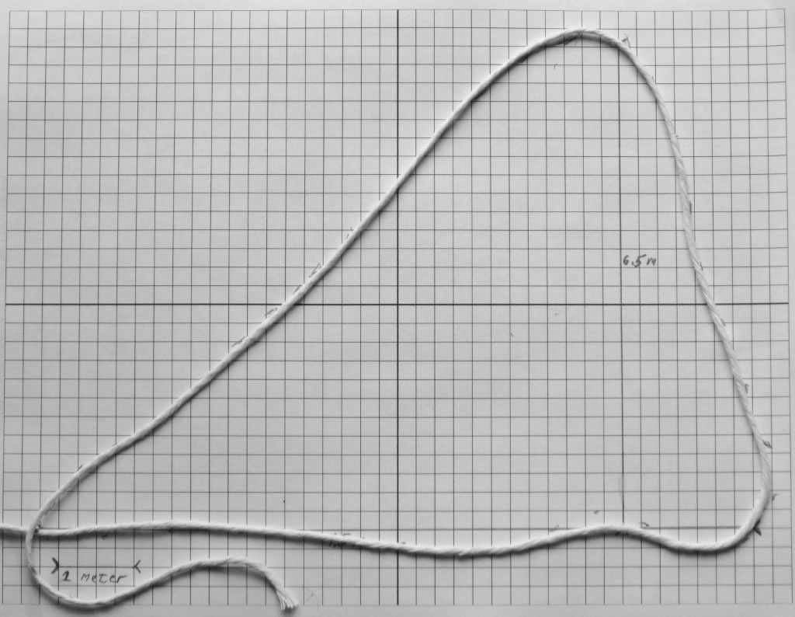

Use a pencil to trace the string with a series of dashes. Once the paper is dry you can connect the dashes and draw a fairly accurate map of the JK stand.

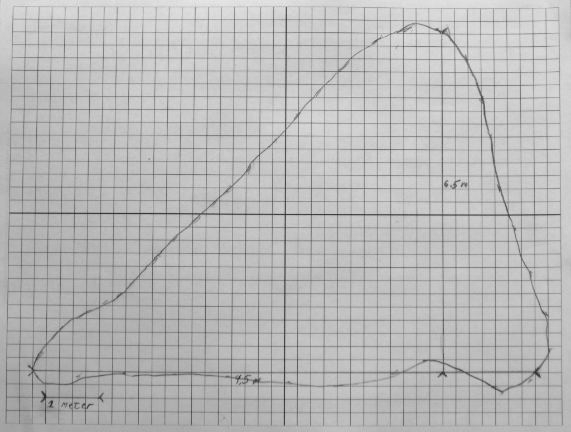

Estimating the area of an irregular shape, the patch of knotweed.

You now have a fairly accurate scale drawing of a patch or stand of knotweed. How do we measure the area of the stand? Do we count all the squares inside the boundary as marked on then graph paper? What do we do if a line goes through a square but does so that some of the square is inside the stand and some is outside the stand? There are many ways of making a decision as how to count partial squares. Discuss the possible ways of doing this and decide as a class how you choose to count partials and why? Whatever rules you decide they must be “fair,” that is a fairly accurate estimate of area. The same rules must also be used in the entire investigation and not be changed. Why is this so?

What is the area of your JK patch in square feet, in square meters. Square feet are converted to square meters by multiplying the square feet by 0.0929. If you measured metrically and want to convert square meters into square feet simply multiply the square meters by 10.764.

Summary this far: You have now located where, if any, stands of JK can be found in your community. In addition, you have have marked the edges of the patch and found their areas. You are now in a great position to see whether and how much these areas are changing from year to year. This is a great stewardship accomplishment!

Here's an excursion into a real Aquatic Invasives problem in the Belgrade Lakes.

The drawing below shows Great Pond. The shoreline is the outside boundary. The yellow area marks all the lake bottom that is 15 feet deep or shallower. Variable leaf milfoil has been found in the pond and can grow to a maximum depth of 15 feet. So any or all of the yellow area can become infested with this aquatic invasive plant. Describe the steps you would take to determine the percentage of surface of this pond that can be maximally infested with Eurasian Milfoil? (You don't have to do the actual calculations, just tell us the sequence of steps you'd take to do it?) Hint: You can print the Great Pond drawing onto a piece of pre-prepared graph paper. (We will do this activity at the workshop)
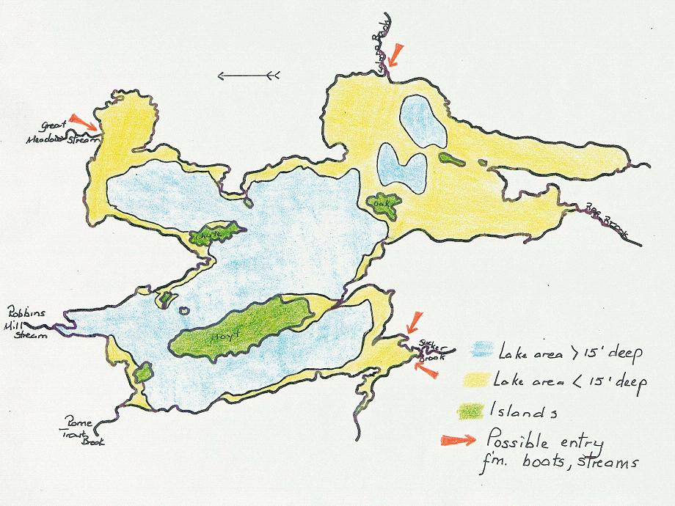

If your class has found JK websites that you feel are useful to this study and the sites are not included on our resource web page, please ask your students to email the web address of the site along with a short one paragraph description of why they think the site is valuable. Include their Team Name and your school name. We will put their recommendation on our site as a link and credit them with the find.

From this point, you may also be picking up work already done by a previous class and accumulating even more information and/or trying to control the spread of this plant.

Note to teacher: Japanese Knotweed is a highly competitive plant that quickly overwhelms nearly all native competition producing an area of growth that is almost a pure stand of knotweed. You may wish to conduct a transect study of plant diversity. Diversity studies are covered elsewhere in this Aquatic Invasives Unit and, consequently, won't be repeated here (see the techniques in the Diversity Activity). A square meter transect study will give you significant results in community diversity loss as your transect penetrates the JK stand and then re-emerges. However, it will be obvious to your students that the number of different plant species growing inside to knotweed stand is much reduced. This species uses various techniques to obliterate its competition. Just cut half the stand down to the ground and watch how fast it recovers! Many aquatic invasives use the same competitive strategies.

Measuring annual change in a previously recorded stand of Japanese knotweed.

Phase I. Mid Spring. Check on the state of your previously measured stands.

Step 1. Spring site maintenance. Before new shoots appear make sure that the boundary flags remained in place and are clearly visible. You may wish to place a ring of clothesline around the flags to clearly show the boundary of the previous year's growth in your photos.

Step 2. Weekly new shoot survey. Ask students who live near the stand to work with the landowners and parents to count the and record the approximate location of new shoots outside the old boundary. The survey should be done on the same day each week. Record the new shoots on a photocopy of the baseline map by placing a dot approximately where each shoot appears. Also measure how far outside the old boundary the furthest distant new shoots are located. Measure and record the distance from the boundary to the most distant new shoot at each survey. Stick a plastic soda straw in the ground next to any recorded shoot so that it is not counted twice. Don't bother counting the new shoots that appear within the old growth, we are really interested in the spreading rate by noting new shoots outside the old boundary. While most new shoots mainly appear in the spring, you will find new shoots throughout the growing season.

Step 3. Annual change report. We want our kids to try to determine when during the growth season the spreading is maximum. We also want them to note how widespread the expansion is because we need this information to best manage our control efforts. Use a different colored felt tip for each survey so that your map shows which week the maximum number of new shoots appear. In the fall when the leaves have all browned the following may be noted:

All the new stalks outside the old boundary will be counted. All the new stalks inside the old boundary will be counted. The percentage of new growth can be produced by comparing the stalk numbers inside the old boundary with those outside the old boundary. Is stalk density the same in new growth areas as in old growth areas?

The new boundary will be flagged and mapped on the old baseline map. Next years field map will be prepared.

The surface area of this year's stand will be estimated using the same area counting rules used for the baseline year. The percentage change of the area from the previous stand's map. New surface area minus old surface area expressed as percent change.

Note any correlation between direction of spread and sunlight levels. Is the stand moving toward sunny exposure, shade?

Note any correlation between direction of spread and soil disturbance. The literature indicates that the plant prefers disturbed soils such as road edges. Is the stand expanding along disturbed soils?
Note any correlation between direction of spread and soil moisture. Is the stand moving toward dryer soils or wetter soils?

Any other changes or questions for further research will be noted and included in the report.

An annual report will be prepared and a synopsis presented to student and adult audiences and prepared as a press release to local papers.

Designing and Conducting Research to control the spread of Japanese Knotweed

A number of control measures can be tried and effectiveness evaluated. All are analogous to measures used to try to control aquatic invasives like milfoil and hydrilla. By this time your students are good scientists and can get involved in higher level inquiry and thinking. They should be able to design research to look at and perhaps even compare various control measures. A bit of warning. The extensive root structure and energy storing capacity of JK makes it very difficult to eradicate in one growing season. This makes eradication a long-term 3 to 5 year effort that must be done in close collaboration with the land owner. If possible, try to find a small patch to try to control (250 square feet or less). While JK has natural enemies in Japan and its growth there is very limited, there are no such natural enemies in the US at this point. Environmental control history on the web is rich with the problems associated with the importation of exotic species as natural controls (e.g. bunnies in Australia, mongooses in Hawaii etc.). Ask your students to web investigate the issue. Do we want to import the beetles and fungi that limit JK in its homeland?

Here are a few ideas you students may wish to investigate:

Plant “control” garden fabrics
(these allow some light penetration and physically attempt to restrain shoots)
Light control barriers (like black plastic “mulch” sheeting) function much like benthic barriers in aquatic management.
Continual cutting of all shoots, mature stalks
Root removal
Herbicides (only applied by adults)
Browsing (eating young shoots only with adult supervision,
See “If You Can't Beat Em Eat Em” appendix)

In experimentation one typically investigates the management of only one variable at a time. Multi-variable experimentation produces confusing results if you haven't already investigated the variables one at a time. So start your control research by trying to manage only one variable either light availability, stored energy in roots, shoot removal (above ground cropping) to limit photosynthesis, etc.

In experimentation you need an hypothesis to test e.g. “limiting light availability to JK with the use of light barriers (silver tarps) will reduce the re-growth of the plant in a given location.” or another option, “limiting light availability to JK with the use of light barriers (silver tarps) will reduce the spread rate of the plant beyond its annual boundary.”

Once you have a couple of seasons of single variable research you might wish to investigate the effectiveness of combined practices like the use of both cutting shoots and light barriers. You can then compare various combinations of practices or a combined practice with a single practice, e.g.Since we already have data on the effectiveness of light barriers and cutting we can now ask the question, “Is the use of light limitation (using silver tarps) and photosynthesis deprivation (using shoot cutting) a more effective practice in controlling the regrowth of JK than the use of either practice alone?”

A good investigation will have the following components:

A description of the problem being investigated. If the investigation is experimental provide the hypothesis being examined. If the investigation is non-experimental (e.g. observational) describe the expected outcome of your research. An non-experimental question might be, “Are more seeds produced per square meter of JK plants growing along roadsides in full sunlight versus those growing along roadsides in partial shade?” Here we don't have the personal experience to produce an hypothesis but still do have a scientifically answerable question. We are just trying to quantify our observations.

A Description of the Methods to be Used in the Investigation (investigation design)

Identification of The Tools and Materials being Used. Includes physical tools, data collection techniques, data recording procedures, data analysis procedures, graphic displays of data etc.

Developing a Data collection Plan: Who, where, when, how

Development of a Data Analysis process: Who, where, when, how

Carrying out of the plan, collecting and analyzing the data

Presenting the Findings: Who, which audience, when, where, how (written, video, web-based etc.)

Identifying Questions for Further Investigation: This is often the most important product.

Development of further research plan.

IF YOU CAN'T BEAT EM EAT EM

Browsing as a control activity for Japanese Knotweed

This activity must be conducted in the spring during the short period of time when new shoots of Japanese Knotweed are emerging and are less than 10 inches from the soil.

Please note that much like rhubarb, the leaves of Japanese Knotweed contain oxalic acid and should not be eaten once unfolded. If the shoots and topmost leaves shown below are not unfolded and are at the right stage. There is no problem eating the top 6 inches of the shoot.

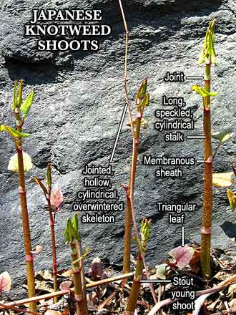
“There are several options for preparing and eating Japanese Knotweed. They've been used in jams, sauces, soups, dessert dishes, or simply steamed like vegetables. Because of its tangy attributes, at times people have substituted cooked Japanese Knotweed for lemon juice which gives mundane recipes a very exotic taste.
When prepared, Japanese Knotweed is an excellent source of vitamins C and A,
potassium, phosphorous, zinc and has been known to have powerful antioxidant
potential. Resveratrol has been known to have a positive impact on bad cholesterol levels (LDL) and aids in the prevention of heart disease. The same substance has been known to reduce the risk and progression of Alzheimer's. Japanese knotweed is cropped commercially as a prime source for resveratrol dietary supplements, which is also found in red wines and the skin of grapes. Large quantities of the plant can also be used as a laxative, much like rhubarb.”
“Up close, the stems are speckled red just like rhubarb, to which it is often compared. Lightly steamed, it has a very pleasant tartness, not the killer tartness that unsweetened rhubarb has. Eating it was really quite delightful. The color of it steamed is an undelightful olive drab, though. I decided to dress it with some soy sauce and toasted sesame oil in honor of its Japanese heritage. I'll serve it room temperature with dinner tonight.”

“Since there are so many things you can make with knotweed, you’ll have no trouble using as much as you harvest. And if you clean and freeze the stems when you get home, you can cook with it at your leisure; it keeps for months in the freezer. Knotweed wine is one of my favorite home brews; it takes less time to finish fermenting than many other wines and tastes like a good sauterne with a tawny gold color. Knotweed can be substituted for rhubarb in pies, jams, and jellies; it combines well with strawberries, blueberries, and apples in “cobbler” or Crisp”. And, yes, you can use knotweed as a vegetable; it’s tart and crunchy in stir-fries and lemony delicious under hollandaise. My favorite way to eat knotweed is in a creamy soup. Nothing like turning environmental activism into lunch”

Here's Ellen Zachos' easy recipe for JK Cream Soup:

Ingredients
 | 1 | lb. knotweed shoots, chopped
 | 1 | large clove garlic, chopped
 | ½ | onion, chopped
 | 4 | cups chicken or vegetable stock
 | ½ | tsp. dried dill or tarragon
 | ~ | Salt and pepper to taste
 | ~ | Sour cream or yogurt as garnish (optional)

Steps
- Put the knotweed stalks, garlic, onion, and stock in a large pot. Bring to a boil, then reduce heat and simmer for about 10 minutes, until everything is tender.
- Purée the mixture with an immersion blender or in a blender or food processor. Add the dill or tarragon and the salt and pepper. The soup should be a little thinner than pea soup; if it’s too thick, add a little water and stir. Serve hot, with a swirl of sour cream or yogurt.

In fact, JK shoots can be used in any recipe that calls for rhubarb. Its tartness is not nearly as strong and when sugared and added to strawberries makes a nice compote or pie filling. My family has been eating it for years and have always enjoyed it. We use only the top five inches of the shoots and either steam or lightly boil it. Unfortunately, it loses most of its color with cooking. Over cooking makes it too soft, although some people enjoy it pureed. We often marinate the steamed stems in rice vinegar, soy sauce and sesame seed oil (just a few drops), chilling it overnight and serving it as a side relish or adding it to our salad, much as we add chilled asparagus. Balsamic vinegar and olive oil works well, too. It can keep in the fridge for days.

Never try new vegetables on any child unless you have the parents permission to do so. I suggest trying a recipe on yourself to see whether you like it. The sweetened desert recipes are more in the taste range of kids. Whenever you try a new veggie there is always the potential for allergy so always consume a teaspoon or less initially and wait 12 hours before consuming a larger amount.

A nice video of the chef in a restaurant in New Haven, CT preparing Japanese Knotweed can be found at Here is the Link: http://www.ctnow.com/videobeta/29f9f53f-a979-49fa-bbed-15fa633bbfd0/News/4-1

An apple and knotweed pie recipe can be found at www.wildmanstevebrill.com/Web Recipes/Apple and Knotweed Pie.html

Some websites suggest eating JK raw. However, since the plant, and especially the mature leaves, contain oxalic acid (albeit much less than rhubarb), cooking is used to reduce the acid content to very safe levels. Don't eat it raw!

One last caution. Be sure that your knotweed patch is growing that has not been contaminated by industrial or construction waste. This stuff loves to grow in disturbed soil and finds a pile of construction waste prime homesteading. It will take in soil contaminant like lead from old paint!

